**Objectives**

IP addresses can change when a packet is forwarded by a device configured with NAT. In this activity, we will investigate what happens to IP addresses during the NAT process.

This uses the file “**12a - Investigating NAT Operation.pka”**  in the iLearn resources. Whenever an activity instructions window pops up, minimize it and use these instructions instead.

Create a doc file named “*L12a-yourlastname.dox*”. Answer the questions in the lab. This will be the only submission for this lab (you do not submit a packet tracer file).

**Topology**

There are three intranets (domains) which are connected via the Internet.

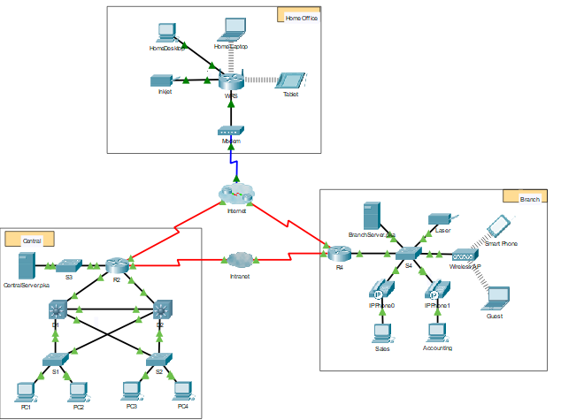

**Step 1: Wait for the network to converge.**

It might take a few minutes for everything in the network to converge. You can speed the process up by clicking on Fast Forward Time.

*Also – change your packet tracer options to buffer only filtered events!*

a. Login to R2 using the password ‘**class**’ to enter privileged EXEC.   
 Enter the command: **show ip nat translations** This should show you the internal (inside local) addresses used by the network.   
 Check the PC’s to ensure they match.

Q1 : How many entries are there in the translation table?

**Step 2: Generate an HTTP request from any PC in the Central domain.**

a. Switch to **Simulation** mode and edit the filters to show only HTTP requests.   
 *NOTE: You may have to select the MISC tab to see the HTTP filters.*

b. Open the Web Browser of any PC in the **Central** domain.  
 Type the following without pressing enter or clicking “go”: h**ttp://branchserver.pka**

c. Click **Go** in the browser, a PDU envelope will appear.   
 ***You may have to click the simulation forward button once to have the envelope appear.***

d. Click **Capture / Forward** until the PDU is over **D1** or **D2**.   
 Then click on the envelope to see the inbound and outbound IP packets.

Q2 : What are the INBOUND SOURCE and DESTINATION IP ADDRESSES?   
 What are the OUTBOUND SOURCE and DESTINATION IP ADDRESSES?   
 Is there any difference between inbound and outbound? Why or Why not?

e. Click **Capture / Forward** until the PDU is over **R2**. Then click on the envelope to see the   
 inbound and outbound IP packets.

Q3 : What are the INBOUND SOURCE and DESTINATION IP ADDRESSES?   
 What are the OUTBOUND SOURCE and DESTINATION IP ADDRESSES?   
 Is there any difference between inbound and outbound? Why or Why not?

f. Login to R2 using ‘**class**’ to enter privileged EXEC and show the running configuration.   
 The address came from the following address pool:

ip nat pool R2Pool 64.100.100.3 64.100.100.31 netmask 255.255.255.224   
  
 This created a pool of available addresses from 64.10.100.**3** to 64.100.100.**31**.   
 Since this is our first NAT picked the first address – 64.10.100.**3**.

g. Click **Capture / Forward** until the PDU is over **R4**.

Q4 : What are the INBOUND SOURCE and DESTINATION IP ADDRESSES?   
 What are the OUTBOUND SOURCE and DESTINATION IP ADDRESSES?   
 Is there any difference between inbound and outbound?

h. On both **R2** and **R4**, run the following command and match the IP addresses and ports recorded above to the correct line of output:

R2# **show ip nat translations**

R4# **show ip nat translations**

Q5 : How has R2’s translation table changed?

**Lab Completion**

Q6 : Write a short description of what NAT is and how it works. Include WHY we use NAT.

Q7. What were the new NAT commands introduced in this module?

Complete and submit file “L12-lastname.docx”

*\*\*\* End of Lab \*\*\**